UNIVERSITY OF THE PEOPLE

MATH 1280-01 - AY2026-T4
Assignment Activity Unit 2
Submitted by: Mubashir Ali
Submitted to: Ifeanyichukwu Ukenazor
Date: 16-April-2026

Question 1: Descriptive Statistics
The dataset consists of the following nine student test scores, arranged in ascending order:
45, 62, 75, 85, 90, 93, 95, 95, 100 (n = 9)
Part (a): Range
The range measures the spread between the highest and lowest values in the dataset (Triola, 2018).

Range = Maximum value − Minimum value
Range = 100 − 45 = 55

The range of the dataset is 55. This indicates a relatively wide spread of scores, suggesting considerable variability in student performance.

Part (b): Quartiles and Percentiles
Using the inclusive formula: L = (p / 100) × (n + 1), where L is the locator value, p is the percentile, and n = 9.

First Quartile (Q1) = 25th Percentile:
L = (25/100) × (9 + 1) = 0.25 × 10 = 2.5
L = 2.5 falls between position 2 (value = 62) and position 3 (value = 75).
Q1 = 62 + 0.5 × (75 − 62) = 62 + 6.5 = 68.5

Third Quartile (Q3) = 75th Percentile:
L = (75/100) × (9 + 1) = 0.75 × 10 = 7.5
L = 7.5 falls between position 7 (value = 95) and position 8 (value = 95).
Q3 = 95 + 0.5 × (95 − 95) = 95 + 0 = 95.0

25th Percentile:
By definition, the 25th percentile equals Q1 = 68.5

50th Percentile:
L = (50/100) × (9 + 1) = 0.50 × 10 = 5.0
L = 5.0 is exactly position 5 (value = 90).
50th Percentile = 90.0

Part (c): Mean, Median, Mode, Variance, and Standard Deviation

Mean:
The mean is the arithmetic average of all values (Triola, 2018):
Mean = (45 + 62 + 75 + 85 + 90 + 93 + 95 + 95 + 100) / 9
Mean = 740 / 9 ≈ 82.22

Median:
With n = 9 (odd), the median is the value at position (9+1)/2 = 5.
The 5th value in the ordered dataset is 90.
Median = 90

Mode:
The value that appears most frequently is 95, which occurs twice.
Mode = 95

Variance and Standard Deviation:
Using the sample variance formula: s² = Σ(x − x̄)² / (n − 1)

x | x̄ | x − x̄ | (x − x̄)²
45 | 82.22 | -37.22 | 1385.49
62 | 82.22 | -20.22 | 408.93
75 | 82.22 | -7.22 | 52.16
85 | 82.22 | 2.78 | 7.72
90 | 82.22 | 7.78 | 60.49
93 | 82.22 | 10.78 | 116.16
95 | 82.22 | 12.78 | 163.27
95 | 82.22 | 12.78 | 163.27
100 | 82.22 | 17.78 | 316.05
Total |  |  | 2673.55

s² = 2673.55 / (9 − 1) = 2673.55 / 8 = 334.19
s = √334.19 ≈ 18.28

Part (d): Comparison of Results from Parts (b) and (c)
A careful comparison of the values computed in Parts (b) and (c) reveals two notable equalities.

Equality 1: 25th Percentile = Q1 = 68.5
This equality is not a coincidence it is definitional. The first quartile (Q1) is, by definition, the value below which 25% of the data falls, making it mathematically identical to the 25th percentile. Both use the same locator formula and yield the same result of 68.5. This relationship always holds true regardless of the dataset (Bluman, 2018).

Equality 2: 50th Percentile = Median = 90
The 50th percentile (P50 = 90) equals the median (90). This is also definitional: the median divides the ordered dataset exactly in half, which is precisely what the 50th percentile measures. With n = 9, the locator L = (50/100) × (9+1) = 5.0 points directly to the 5th value, which is 90 the same as the median. These two measures will always agree, regardless of the dataset (Triola, 2018).

It is worth noting that Q3 = 95.0 does not equal the median (90) or the mean (82.22), as these three measures each describe different aspects of the distribution. The mean is pulled slightly downward by the low score of 45, demonstrating its sensitivity to extreme values.

Question 2: Graphical Representation of Data
The following dataset contains test scores from 25 statistics for students. Before constructing the graphs, the data was sorted in ascending order:
70, 72, 73, 75, 76, 77, 78, 79, 80, 81, 82, 83, 84, 85, 86, 87, 88, 89, 90, 91, 92, 93, 94, 95, 119

Using the IQR method: Q1 = 78, Q3 = 90, IQR = 12. The lower fence = 78 − 1.5(12) = 60.0 and the upper fence = 90 + 1.5(12) = 108.0. The score of 119 lies above the upper fence and is therefore identified as a potential outlier in all three graphs (Bluman, 2018).

Stem-and-Leaf Plot
The stem-and-leaf plot displays each score using its tens digit as the stem and its units digit as the leaf. The score 119 (stem = 11) is marked with an asterisk (*) to identify it as a potential outlier.

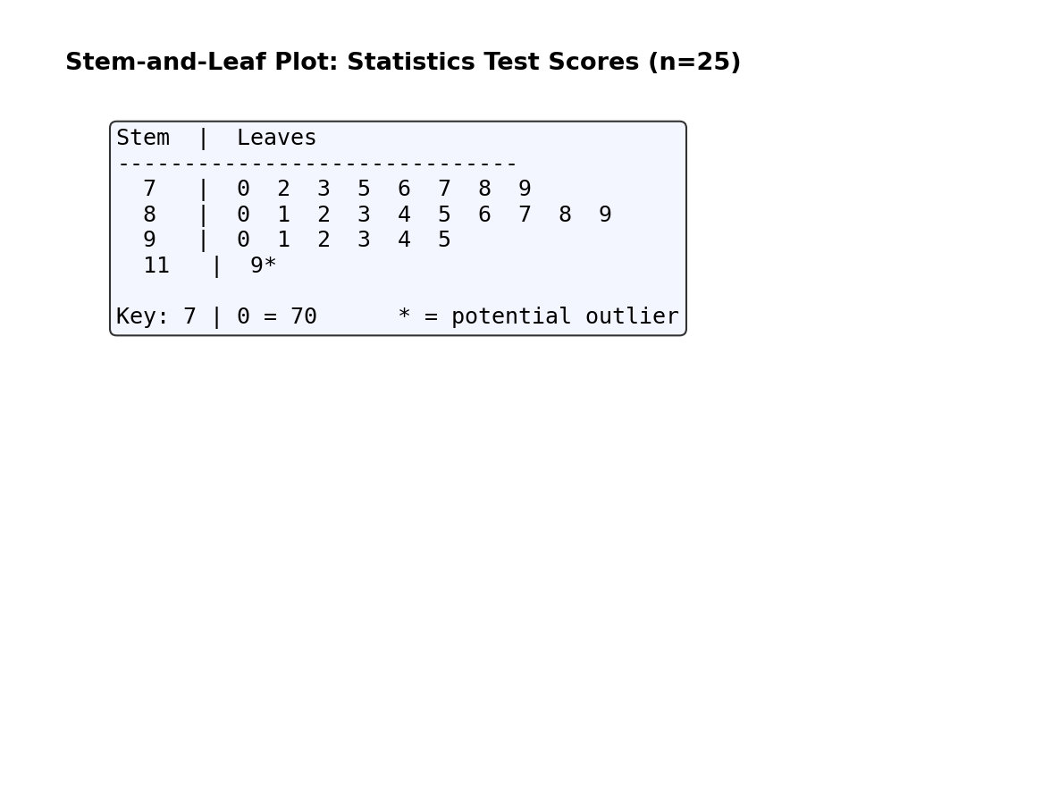
Figure 1. Stem-and-Leaf Plot of Statistics Test Scores (n = 25). * denotes potential outlier.

The plot reveals that the majority of scores are concentrated in the 70s, 80s, and 90s, forming a fairly symmetric cluster. The score of 119* is clearly isolated from the main distribution, confirming its status as an outlier.

Histogram
The histogram groups scores into class intervals of width 6. The bin containing the outlier (113–119) is highlighted in red. The upper fence (108.0) is shown as a dashed red line.

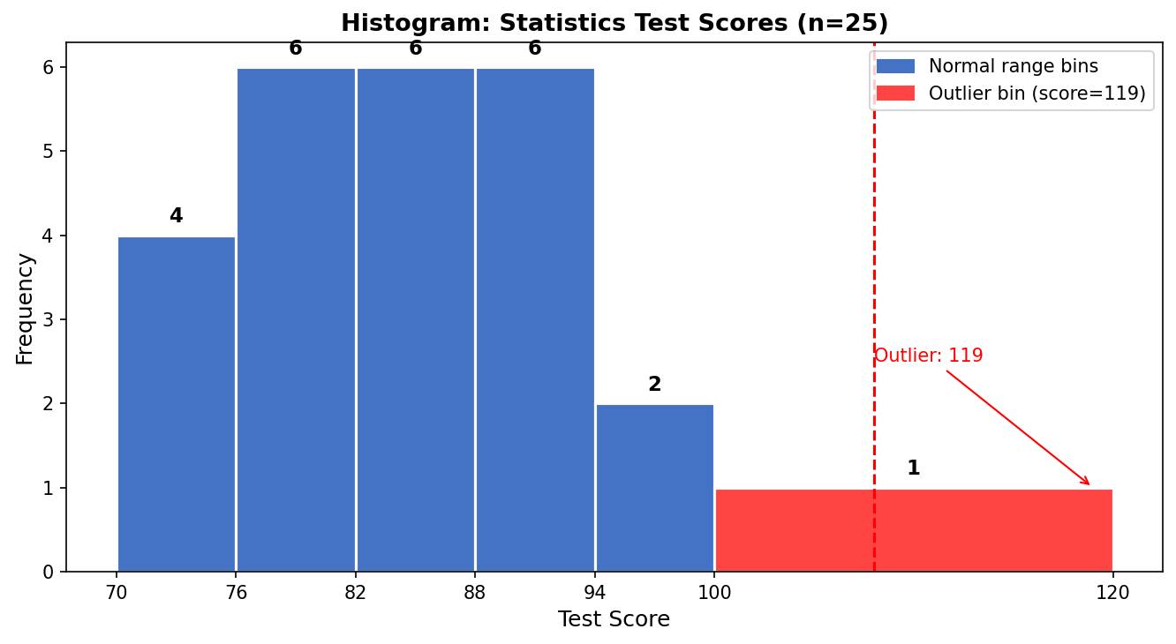
Figure 2. Histogram of Statistics Test Scores (n = 25). Red bin and dashed line indicate the outlier region.

The histogram confirms that scores are concentrated between 70 and 100, with the distribution approximately bell-shaped. The isolated red bar at the far right (containing the score of 119) is visually distinct, reinforcing its identification as an outlier.

Box Plot
The box plot (box-and-whisker plot) displays the five-number summary: Minimum = 70, Q1 = 78, Median = 84, Q3 = 90, Maximum (non-outlier) = 95. The score of 119 is plotted as a separate red point beyond the upper whisker.

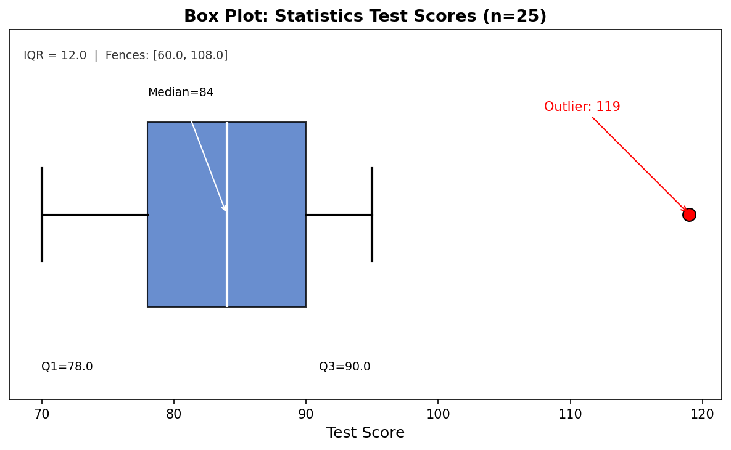
Figure 3. Box Plot of Statistics Test Scores (n = 25). Red circle at 119 is a potential outlier.

The box plot most clearly highlights the outlier: the whisker extends only to 95 (the largest non-outlier value), and 119 appears as an isolated red dot far to the right. The relatively compact box (IQR = 12) confirms that most scores cluster tightly around the median of 84.

References
Bluman, A. G. (2018). Elementary statistics: A step by step approach (10th ed.). McGraw-Hill Education.
Triola, M. F. (2018). Elementary statistics (13th ed.). Pearson.

